2.4 select sname, sp.sno, pno from s join sp on s.sno = sp.sno where pno not in (select pno from sp where sno = 's3')

select sname, sp.sno, sp.pno from s join sp on s.sno = sp.sno where not exists (select \* from sp as sp2 where sp2.sno = 's3' and sp.pno = sp2.pno)

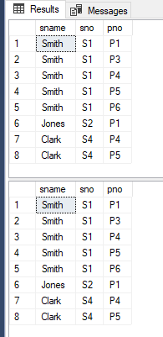

2.5 select pno, sname from s join sp on s.sno = sp.sno where exists (select \* from sp as sp2 where sp2.pno < sp.pno)

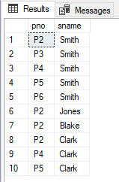 This is as far as I got.

2.6 select distinct p.pno, p.pname from p join sp on sp.pno = p.pno where p.pno in (select pno from sp group by pno having count(\*) = (select count(\*) from s))



2.7 select s.sno, sname from sp join s on s.sno = sp.sno where exists (select \* from sp where sp.sno = 's7') 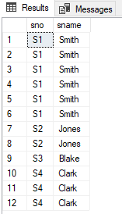 This was as far as I could get.

2.8 select top 1 s.sno, sname, sum(qty) qty from sp join s on s.sno = sp.sno group by s.sno, sname order by qty desc

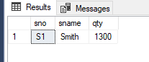

2.9 select sp.sno, sname from sp join p on p.pno = sp.pno join s on s.sno = sp.sno where color = 'red' and sp.sno not in (select sp.sno from sp join p on p.pno = sp.pno where color != 'red')



2.10 delete from sp where sp.sno = 's1' and sp.pno = 'p2'

insert into sp (SNO, PNO, QTY)

values

('S1', 'P2', '200')

Before delete

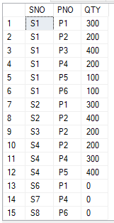After delete

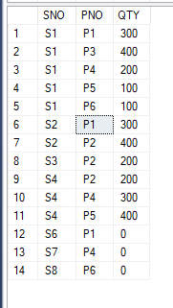After insert 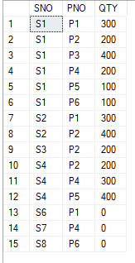

2.11 delete from s where sno = 's3'

delete from sp where sno = 's3'

Before delete 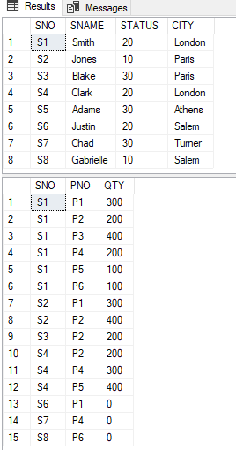

After delete 